Crop Prediction Using Machine Learning

1. INTODRODUCTION

1.1 OVERVIEW

Farming has been the backbone of human civilization since the beginning of time. Farmers are responsible for feeding the world's population, and their efforts are critical in ensuring food security. However, selecting the best crop for a farm can be a daunting task, and farmers face several challenges in this regard. selecting crops is soil suitability. These challenges include different soil requirements based on Nitrogen, Phosphorus, Potassium content in the soil, different PH value of soil ,variability in climate of a region based on humidity, rainfall, temperature of a particular region. Therefore, selecting the best crop for a farm is tedious job for farmers nowadays and it requires careful consideration of several factors. Catering to all the challenges stated above, we have developed a model which can predict up to 21 Crops when given features based on soil content and climate-based factors of a particular region as input. This model can be used by farmers for predicting best crop for their farm in order to maximize their farm yield and also their profits through farming .

1.2 PURPOSE

Crop prediction serves several important purposes in agriculture and food production. It involves forecasting the likely yield and quality of crops before they are harvested. This prediction is based on historical data, current conditions, and advanced technologies. Crop prediction models are easy to use, even for those without specialized technical knowledge. Farmers and other stakeholders in the agricultural industry may not have technical expertise in data analytics or machine learning. The interface should be easy to use and understand by the user. The model should not ask inputs for which the user does not have answers.

2. LITERATURE SURVEY

2.1 EXISTING PROBLEM

In the existing system there where many problems to find suitable crop yield for the land. It will take a lot of time to find the crop to yield. Crop yield varies from year to year making crop management difficult and affecting food security. The computational and data demands of structural price forecasting generally far exceed than what is routinely available in developing countries. Consequently, researchers often rely on parsimonious representations of price processes for their forecasting needs. Contemporary parsimonious form of price forecasting relies heavily on

time series modelling. In time series modelling, past observations of the same variable are collected and analyzed to develop a model describing the underlying relationship. During the past few decades, much effort has been devoted to the development and improvement of time series forecasting models.

2.2 PROPOSED SOLUTION

In proposed system, mplement the crop selection method so that this method helps in solving many agriculture and farmers problems.Here the users of site with crop prediction can predict crops suitable for the selected land scientifically using machine learning and this would also help the users to improve cultivation in a cost effective manner by predicting the most suitable crops for the specific season and place, it provide everything on finger tips, This website is created for the purpose of reduce farmers work and attracting new people to the agriculture. This improves our Indian economy by maximizing the yield rate of crop production. Different types of land condition. So the quality of the fertilizers are identified using ranking process.

3. THEORITICAL ANALYSIS

3.1 BLOCK DIAGRAM

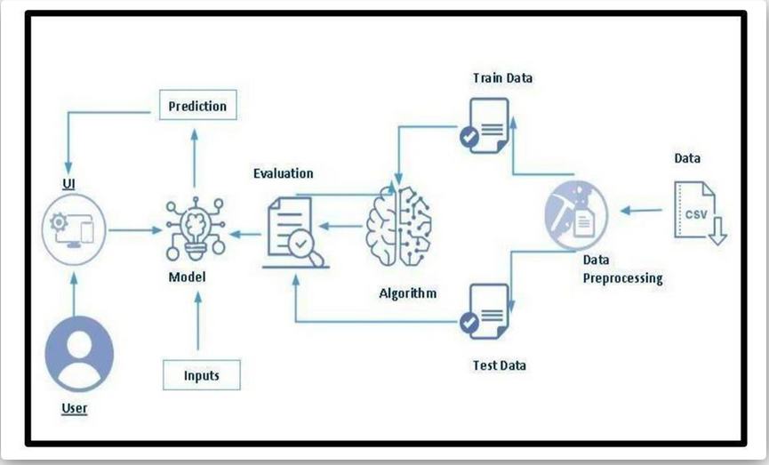

3.2 HARDWARE AND SOFTWARE DESIGNING

Python

Python is an interpreted, object-oriented, high-level programming language with dynamic semantics. It was created by Guido van Rossum , and first released on February 20, 1991. Its high-level built in data structures, combined with dynamic typing and dynamic binding , make it very attractive for Rapid Application Development, as well as for use as a scripting or glue language to connect existing components together. Python's simple, easy to learn syntax emphasizes readability and therefore reduces the cost of program maintenance. Python supports modules and packages, which encourages program modularity and code reuse. The Python interpreter and the extensive standard library are available in source or binary form without charge for all major platforms, and can be freely distributed.

Anaconda Navigator

Anaconda Navigator is a free and open-source distribution of the Python and R programming languages for data science and machine learning related applications. It can be installed on Windows, Linux, and macOS.Conda is an open-source, crossplatform, package management system. Anaconda comes with so very nice tools like JupyterLab, Jupyter Notebook, QtConsole, Spyder, Glueviz, Orange, Rstudio, Visual Studio Code. For this project, we will be using Jupyter notebook and Spyder.
Google Colab
Google Colaboratory, or "Colab" as most people call it, is a cloud-based Jupyter notebook environment. It runs in your web browser (you can even run it on your favorite chromaebook) and lets anyone with internet access experiment with machine learning and coding for artificial intelligence. You can write and execute python code, share your code and edit it simultaneously with other team members, and document everything by combining it into a single notebook with rich text, charts, images, HTML, and LaTeX.
Visual Studio Code

Visual Studio Code (famously known as VS Code) is a free open source text editor by Microsoft. VS Code is available for Windows, Linux, and macOS. Although the editor is relatively lightweight, it includes some powerful features that have made VS Code one of the most popular development environment tools in recent times.VS Code supports a wide array of programming languages from Java, C++, and Python to CSS, Go, and Dockerfile. Moreover, VS Code allows you to add on and even creating new extensions including code linters, debuggers, and cloud and web development support.

Flask

Webframework used for building. It is a web application framework written in python which will be running in local browser with a user interface. In this application, whenever the user interacts with UI and selects emoji, it will suggest the best and top movies of that genre to the user.

HARDWARE REQUIREMENTS

Operating system: window 7 and above with 64bit Processor Type -Intel
Core i3-3220
RAM: 4Gb and above

Hard disk: min 100GB

4. EXPERIMENTAL INVESTIGATIONS

The text data need to be organized before proceeding with the project. The original dataset has a single folder. We will be using the crop_recommenation.csv file to fetch the text data of training data. The datas need to be unique and all fields need to be filled.The dataset images are to be pre-processed before giving to the model. We will create a function that uses the pre-trained model for predicting custom outputs. Then we have to test and train the model. After the model is build, we will be integrating it to a web application.

5. FLOWCHART
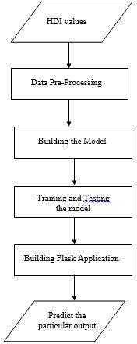

6. RESULTS

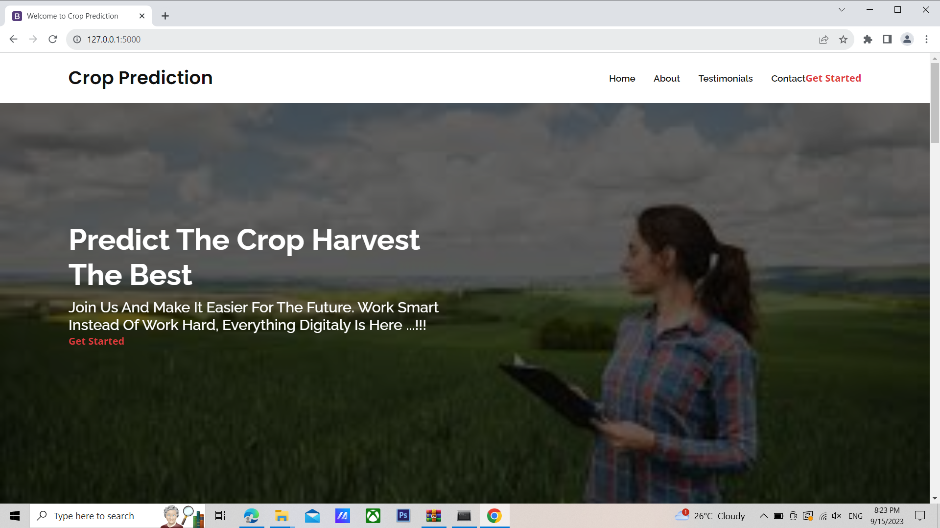

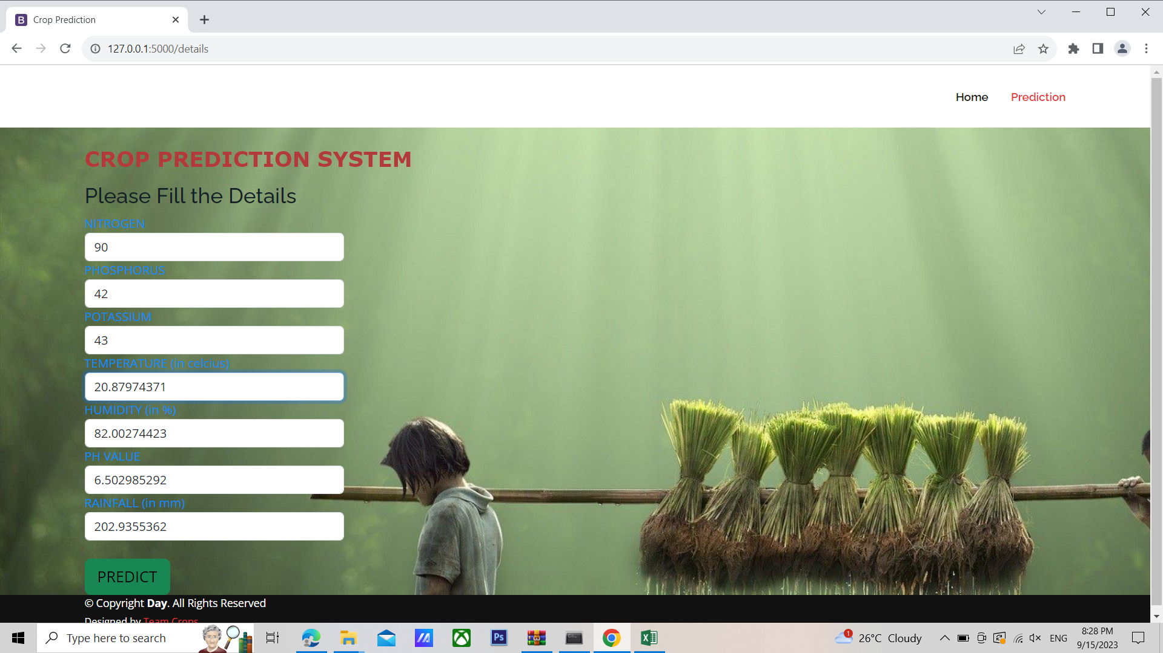

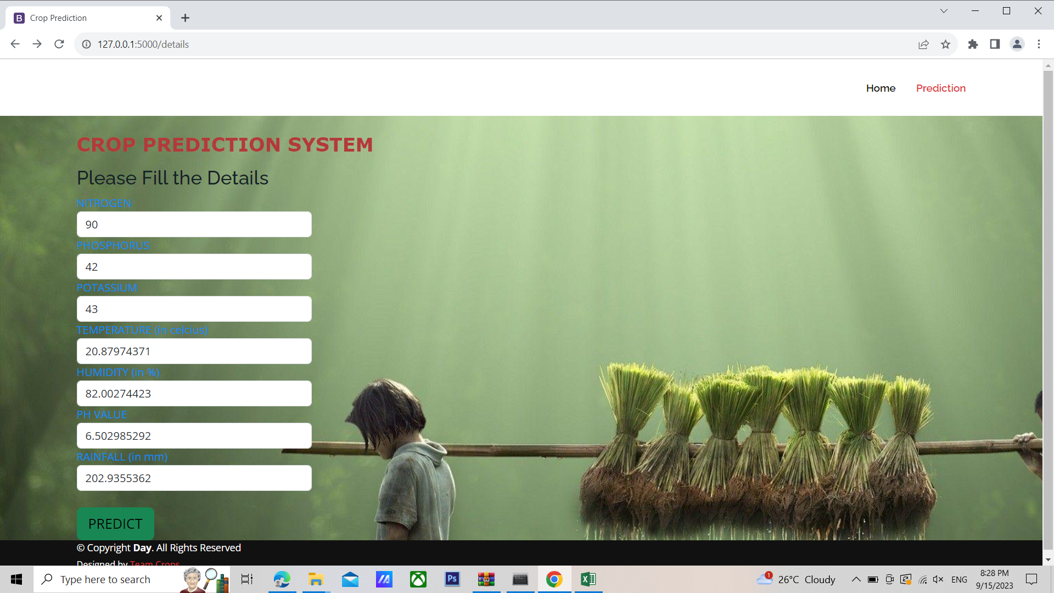

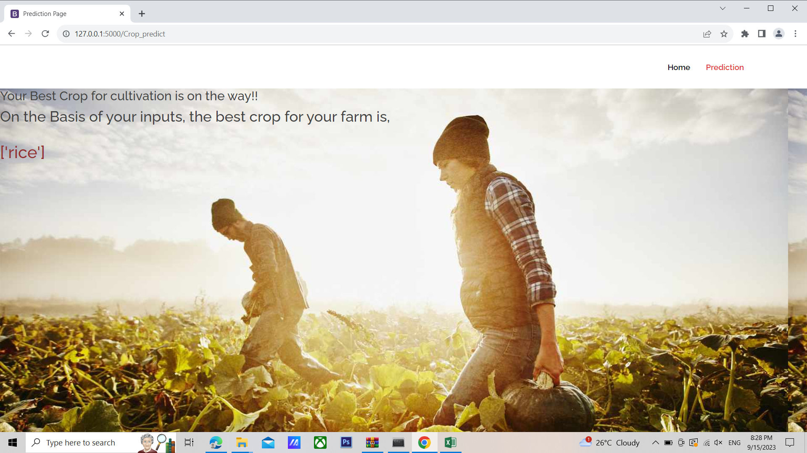

7. ADVANTAGES AND DISADVANTAGES

ADVANTAGES

- Easy to use
- Cost efficient
- Time efficient
- Crop prediction accuracy helps farmers to get better cultivation and yield by using this technique.

DISADVANTAGES

- Machine learning models require large amounts of high-quality data for training.
- Machine learning models for crop prediction can be complex, requiring significant computational resources for training and deployment. This can be a barrier for adoption in resource-constrained areas.

8. APPLICATIONS

- ML models can analyze images of crops to detect early signs of diseases or pest infestations. Early detection allows for timely intervention, reducing crop losses.
- Machine learning can forecast the emergence of specific pests or diseases based on historical data and environmental factors, allowing proactive pest and disease management.

9. CONCLUSION

In conclusion, crop prediction using machine learning represents a transformative advancement in modern agriculture. This technology harnesses the power of data, algorithms, and predictive modeling to revolutionize how farmers plan, manage, and optimize their crop production. We can create more precise predictions about how a specific crop will perform in a specific place by creating a model that takes into consideration a variety of parameters that can affect crop growth, such as nitrogen, phosphorous, potassium levels in the soil, temperature, humidity, pH, and rainfall. The model can learn from past data and get better at making predictions over time by utilising machine learning algorithms.

10. FUTURE SCOPE

The future scope for crop prediction using machine learning is promising and holds the potential for significant advancements in agriculture. Future models may offer predictions for multi-crop systems and provide recommendations for crop rotation strategies that optimize soil health and reduce the risk of diseases and pests.

11. BIBILOGRAPHY

https://www.irejournals.com/formatedpaper/1704207.pdf
https://www.slideshare.net/dataalcott/crop-prediction-using-machine-learning

APPENDIX

A. SOURCE CODE

app.py

from flask import Flask, render_template, request
import pandas as pd
import numpy as np
import pickle
model =pickle.load(open('model.pkl','rb'))
app=Flask(__name__)
@app.route('/')
def home():
return render_template('index.html')
@app.route('/details') # rendering the html template
def index() :
return render_template('details.html')
@app.route('/Crop_predict', methods=['GET','POST'])
def predict() :
# loading model which we saved
N = float(request.form['N'])
P = float(request.form['P'])

K = float(request.form['K'])
temperature= float(request.form['temperature'])
humidity = float(request.form['humidity'])
ph= float(request.form['ph'])
rainfall = float(request.form['rainfall'])
prediction =model.predict(pd.DataFrame([[N,P,K, temperature, humidity, ph, rainfall]],
columns= ['N', 'P', 'K', 'temperature', 'humidity', 'ph','rainfall']))
return render_template('Crop_predict.html', prediction_text ="{}".format(prediction))
if __name__ == '__main__':
app.run(debug = True)

index.html
<!DOCTYPE html>
<html lang="en">
<head>
<meta charset="utf-8">
<meta content="width=device-width, initial-scale=1.0" name="viewport">
<title>Welcome to Crop Prediction</title>
<meta content="" name="description">
<meta content="" name="keywords">
<link href="../static/img/favicon.PNG" rel="icon">
<link href="../static/img/apple-touch-icon.PNG" rel="apple-touch-icon">
<link href="https://fonts.googleapis.com/css?family=Open+Sans:300,300i,400,400i,600,600i,700,700i|Raleway:300,300i,400,400i,500,500i,600,600i,700,700i|Poppins:300,300i,400,400i,500,500i,600,600i,700,700i" rel="stylesheet">
<link href="../static/vendor/aos/aos.css" rel="stylesheet">
<link href="../static/vendor/bootstrap/css/bootstrap.min.css" rel="stylesheet">
<link href="../static/vendor/bootstrap-icons/bootstrap-icons.css" rel="stylesheet">
<link href="../static/vendor/boxicons/css/boxicons.min.css" rel="stylesheet">
<link href="../static/vendor/glightbox/css/glightbox.min.css" rel="stylesheet">
<link href="../static/vendor/remixicon/remixicon.css" rel="stylesheet">
<link href="../static/vendor/swiper/swiper-bundle.min.css" rel="stylesheet">
<link href="../static/css/style.css" rel="stylesheet">
<style type="text/css">
</style>
</head>
<body>
<header id="header" class="fixed-top d-flex align-items-center">
<div class="container d-flex align-items-center">
<h1 class="logo me-auto"><a href="index.html">Crop Prediction</a></h1>
<nav id="navbar" class="navbar order-last order-lg-0">
<ul>
<li><a href="#hero">Home</a></li>
<li><a href="#testimonials">About</a></li>
<li><a href="#testimonials">Testimonials</a></li>
<li><a href="#contact">Contact</a></li>
</ul>
<i class="bi bi-list mobile-nav-toggle"></i>
<a class="btn-book-a-table" href="/details" title="Click here to make your prediction" onclick="showLoadingAnimation()"><b>Get Started</b></a>
<i class="mobile-nav-toggle mobile-nav-show bi bi-list"></i>
<i class="mobile-nav-toggle mobile-nav-hide d-none bi bi-x"></i>
</div>
<section id="hero" class="d-flex align-items-center">
<div class="container" data-aos="zoom-out" data-aos-delay="100">
<div class="row">
<div class="col-xl-6">
<h1>Predict The Crop Harvest The Best</h1>
<h2>Join Us And Make It Easier For The Future. Work Smart Instead Of Work Hard, Everything Digitaly Is Here ...!!! </h2>
<a href="/details" class="btn-book-a-table"><b>Get Started</b></a>
</div>
</div>
</div>
<main id="main">
<section id="why-us" class="why-us section-bg">
<div class="container" data-aos="fade-up">
<div class="row gy-4">
<div class="col-lg-4" data-aos="fade-up" data-aos-delay="100">
<div class="why-box">
<h3>Why prediction of best crop for cultivation matters?</h3>
<p>
The prediction of the best crop for cultivation is a critical aspect of agricultural planning and management. It helps farmers optimize their resources, reduce risk, and maximize their economic returns.
</p>
<div class="text-center">
<a href="#" class="more-btn">Learn More <i class="bx bx-chevron-right"></i></a>
</div>
</div>
</div>
<div class="col-lg-8 d-flex align-items-center">
<div class="row gy-4">
<div class="col-xl-4" data-aos="fade-up" data-aos-delay="200">
<div class="icon-box d-flex flex-column justify-content-center align-items-center">
<i class="bi bi-heart"></i>
<h4>Improved crop yield</h4>
<p>By predicting the best crop for cultivation, farmers can select crops that are best suited for their specific soil and environmental conditions. This leads to an increase in crop yield, as the selected crop will be able to grow and thrive optimally.</p>
</div>
</div>
<div class="col-xl-4" data-aos="fade-up" data-aos-delay="200">
<div class="icon-box d-flex flex-column justify-content-center align-items-center">
<i class="bi bi-bicycle"></i>
<h4>Resource management</h4>
<p>Choosing the best crop for cultivation can also help farmers manage resources efficiently. For example, certain crops may require less water or fertilizer, which can help reduce costs and conserve resources.</p>
</div>
</div>
<div class="col-xl-4" data-aos="fade-up" data-aos-delay="400">
<div class="icon-box d-flex flex-column justify-content-center align-items-center">
<i class="bi bi-bug"></i>
<h4>Risk mitigation</h4>
<p> It can help farmers mitigate risks associated with crop failure. By selecting a crop that is well-suited for the local climate and soil conditions, farmers can reduce the risk of crop failure due to adverse weather conditions, pests, or diseases.</p>
</div>
</div>
</div>
</div>
</div>
</div>
</section>
<section id="stats-counter" class="stats-counter">
<div class="container" data-aos="zoom-out">
<div class="row gy-4">
<div class="col-lg-4 col-md-6">
<div class="stats-item text-center">
<span data-purecounter-start="0" data-purecounter-end="5069" data-purecounter-duration="1" class="purecounter"></span>
<p>Rural_Farmers</p>
</div>
</div>
<div class="col-lg-4 col-md-6">
<div class="stats-item text-center">
<span data-purecounter-start="0" data-purecounter-end="3500" data-purecounter-duration="1" class="purecounter"></span>
<p>Urban_Farmers</p>
</div>
</div>
</div>
</div>
</section>
<section id="about" class="about section-bg">
<div class="container" data-aos="fade-up">
<div class="row no-gutters">
<div class="content col-xl-5 d-flex align-items-stretch">
<div class="content">
<h3>How Crop prediction is important to farmers</h3>
<p>
Selecting the best crop for cultivation can also have significant economic benefits. By selecting crops that have a high market value and are in demand, farmers can maximize their profits.
</p>
<a href="#" class="about-btn"><span>About us</span> <i class="bx bx-chevron-right"></i></a>
</div>
</div>
<div class="col-xl-7 d-flex align-items-stretch">
<div class="icon-boxes d-flex flex-column justify-content-center">
<div class="row">
<div class="col-md-6 icon-box" data-aos="fade-up" data-aos-delay="100">
<i class="bx bx-receipt"></i>
<h4>How we are Helping out Farmers</h4>
<p>We are helping out farmers by analyzing their farm's soil content like amount of N, P, K in their soil. As well as
By considering temperature, Humidity and PH level of their farm,s soil and predict the best crop for cultivation so that they can maximize their profits </p>
</div>
</div>
</div>
</div>
</div>
</div>
</section>
<section id="counts" class="counts">
<div class="container" data-aos="fade-up">
<div class="row">
<div class="col-lg-3 col-md-6">
<div class="count-box">
<i class="bi bi-emoji-smile"></i>
<span data-purecounter-start="0" data-purecounter-end="10000" data-purecounter-duration="1" class="purecounter"></span>
<p>Website Visited Farmars</p>
</div>
</div>
<div class="col-lg-3 col-md-6 mt-5 mt-md-0">
<div class="count-box">
<i class="bi bi-journal-richtext"></i>
<span data-purecounter-start="0" data-purecounter-end="8569" data-purecounter-duration="1" class="purecounter"></span>
<p>Happy Farmers</p>
</div>
</div>
<div class="col-lg-3 col-md-6 mt-5 mt-lg-0">
<div class="count-box">
<i class="bi bi-headset"></i>
<span data-purecounter-start="0" data-purecounter-end="1463" data-purecounter-duration="1" class="purecounter"></span>
<p>Hours Of Support</p>
</div>
</div>
</div>
</div>
</section>
<section id="testimonials" class="testimonials">
<div class="container" data-aos="fade-up">
<div class="section-title">
<h2>Testimonials</h2>
<p>What Are They <span>Saying About Us</span></p>
</div>
<div class="testimonials-slider swiper" data-aos="fade-up" data-aos-delay="100">
<div class="swiper-wrapper">
<div class="swiper-slide">
<div class="testimonial-wrap">
<div class="testimonial-item">
<img src="static/img/testimonials/testimonials.PNG" class="testimonial-img" alt="">
<h3>Shantaram Naik</h3>
<h4>Urban Farmar</h4>
<p>
<i class="bx bxs-quote-alt-left quote-icon-left"></i>
I've been using this website to get best crop for cultivation for a few weeks now and I'm really impressed with the results. It's been so helpful as it increases my profitability!
<i class="bi bi-quote quote-icon-right"></i>
</p>
</div>
</div>
</div>
<div class="swiper-slide">
<div class="testimonial-wrap">
<div class="testimonial-item">
<img src="static/img/testimonials/testimonials-1.PNG" class="testimonial-img" alt="">
<h3>Rohit kumar</h3>
<h4>Rural farmer</h4>
<p>
<i class="bx bxs-quote-alt-left quote-icon-left"></i>
This websit very useful as it increses my profits over the years
<i class="bx bxs-quote-alt-right quote-icon-right"></i>
</p>
</div>
</div>
</div>
<div class="swiper-slide">
<div class="testimonial-wrap">
<div class="testimonial-item">
<img src="static/img/testimonials/testimonials-5.PNG" class="testimonial-img" alt="">
<h3>Jithesh mishra</h3>
<h4>Store Owner</h4>
<p>
<i class="bx bxs-quote-alt-left quote-icon-left"></i>
This website help farmaers a lot as their production has been increased over the years which increase my profitability as store owner
<i class="bx bxs-quote-alt-right quote-icon-right"></i>
</p>
</div>
</div>
</div>
</div>
<div class="swiper-pagination"></div>
</div>
</div>
</section>
<section id="contact" class="contact">
<div class="container" data-aos="fade-up">
<div class="section-title">
<h2>Contact</h2>
<p>Need Help? <span>Contact Us</span></p>
</div>
<div class="row" data-aos="fade-up" data-aos-delay="100">
<div class="col-lg-6">
<div class="row">
<div class="col-md-12">
<div class="info-box">
<i class="bx bx-map"></i>
<h3>Our Address</h3>
<p>SCIT, Hinjewadi ,Pune 411017</p>
</div>
</div>
<div class="col-md-6">
<div class="info-box mt-4">
<i class="bx bx-envelope"></i>
<h3>Email Us</h3>
<p>predictors@associates.scit.edu</p>
</div>
</div>
<div class="col-md-6">
<div class="info-box mt-4">
<i class="bx bx-phone-call"></i>
<h3>Call Us</h3>
<p>+1 5589 55488 55<br>+1 6678 254445 41</p>
</div>
</div>
</div>
</div>
<div class="col-lg-6">
<form action="forms/contact.php" method="post" role="form" class="php-email-form">
<div class="row">
<div class="col form-group">
<input type="text" name="name" class="form-control" id="name" placeholder="Your Name" required>
</div>
<div class="col form-group">
<input type="email" class="form-control" name="email" id="email" placeholder="Your Email" required>
</div>
</div>
<div class="form-group">
<input type="text" class="form-control" name="subject" id="subject" placeholder="Subject" required>
</div>
<div class="form-group">
<textarea class="form-control" name="message" rows="5" placeholder="Message" required></textarea>
</div>
<div class="my-3">
<div class="loading">Loading</div>
<div class="error-message"></div>
<div class="sent-message">Your message has been sent. Thank you!</div>
</div>
<div class="text-center"><button type="submit">Send Message</button></div>
</form>
</div>
</div>
</div>
</section>
</main>
<footer id="footer">
<div class="footer-top">
<div class="container">
<div class="row">
<div class="col-lg-3 col-md-6 footer-contact">
<h3>Crop Prediction</h3>
<p>
SCIT <br>
Hinjewadi<br>
Pune<br><br>
<strong>Phone:</strong> +1 5589 55488 55<br>
<strong>Email:</strong> predictors@associates.scit.edu<br>
</p>
</div>
<div class="col-lg-3 col-md-6 footer-links">
<h4>Follow Us</h4>
<div class="social-links d-flex">
<a href="#" class="twitter"><i class="bi bi-twitter"></i></a>
<a href="#" class="facebook"><i class="bi bi-facebook"></i></a>
<a href="#" class="instagram"><i class="bi bi-instagram"></i></a>
<a href="#" class="linkedin"><i class="bi bi-linkedin"></i></a>
</div>
</div>
</div>
</div>
<div class="container">
<div class="copyright">
&copy; Copyright <strong><span>Crop Prediction</span></strong>. All Rights Reserved
</div>
<div class="credits">
Designed by <a href="https://bootstrapmade.com/">Team Crops</a>
</div>
</div>
</footer>
<a href="#" class="scroll-top d-flex align-items-center justify-content-center"><i class="bi bi-arrow-up-short"></i></a>
<div id="preloader"></div>
<script src="../static/vendor/bootstrap/js/bootstrap.bundle.min.js"></script>
<script src="../static/vendor/aos/aos.js"></script>
<script src="../static/vendor/glightbox/js/glightbox.min.js"></script>
<script src="../static/vendor/purecounter/purecounter_vanilla.js"></script>
<script src="../static/vendor/swiper/swiper-bundle.min.js"></script>
<script src="../static/vendor/php-email-form/validate.js"></script>
<script src="../static/js/main.js"></script>
<script>
function showLoadingAnimation() {
var loader = document.createElement("div");
loader.innerHTML = "Loading...";
loader.classList.add("loader");
document.body.appendChild(loader);
setTimeout(function() {
window.location.href = "/predict";
}, 1000);
}
</script>
</body>
</html>

details.html

<!DOCTYPE html>
<html lang="en">
<head>
<meta charset="utf-8">
<meta content="width=device-width, initial-scale=1.0" name="viewport">
<title>Crop Prediction</title>
<meta content="" name="description">
<meta content="" name="keywords">
<link href="../static/img/favicon.PNG" rel="icon">
<link href="../static/img/apple-touch-icon.PNG" rel="apple-touch-icon">
<link href="https://fonts.googleapis.com/css?family=Open+Sans:300,300i,400,400i,600,600i,700,700i|Raleway:300,300i,400,400i,500,500i,600,600i,700,700i|Poppins:300,300i,400,400i,500,500i,600,600i,700,700i" rel="stylesheet">
<link href="../static/vendor/aos/aos.css" rel="stylesheet">
<link href="../static/vendor/bootstrap/css/bootstrap.min.css" rel="stylesheet">
<link href="../static/vendor/bootstrap-icons/bootstrap-icons.css" rel="stylesheet">
<link href="../static/vendor/boxicons/css/boxicons.min.css" rel="stylesheet">
<link href="../static/vendor/glightbox/css/glightbox.min.css" rel="stylesheet">
<link href="../static/vendor/swiper/swiper-bundle.min.css" rel="stylesheet">
<link href="../static/css/style.css" rel="stylesheet">
<style type="text/css">
body {
background-image: url("../static/img/front4.jpg");
}
</style>
</head>
<body>
</section>
<header id="header" class="d-flex align-items-center">
<div class="container d-flex align-items-center justify-content-between">
<h1 class="logo"><a href="index.html">Crop Prediction</a></h1>
<nav id="navbar" class="navbar">
<ul>
<li><a class="" href="index.html">Home</a></li>
<li><a class="nav-link scrollto active" href="#portfolio">Prediction</a></li>
</ul>
</nav>
</div>
</header>
<div class="content">
<div class="container">
<div class="row">
<div class="col-md-8">
<div class="box">
<h3 class="heading" style="color:rgb(10, 176, 29)">Please Fill the Details</h3>
<form action="{{ url_for('predict')}}"method="post">
<div class="form-group row">
<div class="col-md-5">
<label for="N" style="color:rgba(16, 5, 5, 0.91)">NITROGEN</label>
<input type="text" class="form-control" name="N" id="N" required="required" />
</div>
</div>
<div class="form-group row">
<div class="col-md-5">
<label for="P" style="color:rgba(16, 5, 5, 0.91)">PHOSPHOURS</label>
<input type="text" class="form-control" name="P" id="P" required="required" />
</div>
</div>
<div class="form-group row">
<div class="col-md-5">
<label for="K" style="color:rgba(16, 5, 5, 0.91)" >POTASSIUM</label>
<input type="text" class="form-control" name="K" id="K" required="required" />
</div>
</div>
<div class="form-group row">
<div class="col-md-5">
<label for="temperature" style="color:rgba(16, 5, 5, 0.91)">TEMPERATURE (in celcius)</label>
<input type="text" class="form-control" min="0" max="100" name="temperature" id="temperature" required="required" />
</div>
</div>
<div class="form-group row">
<div class="col-md-5">
<label for="humidity"style="color:rgba(16, 5, 5, 0.91)">HUMIDITY (in %)</label>
<input type="text" class="form-control" min="0" max="100" name="humidity" id="humidity" required="required" />
</div>
</div>
<div class="form-group row">
<div class="col-md-5">
<label for="ph" style="color:rgba(16, 5, 5, 0.91)">PH VALUE</label>
<input type="text" class="form-control" min="0" max="14" name="ph" id="ph" required="required" />
</div>
</div>
<div class="form-group row">
<div class="col-md-5">
<label for="rainfall" style="color:rgba(16, 5, 5, 0.91)">RAINFALL (in mm)</label>
<input type="text" class="form-control" min="0" name="rainfall" id="rainfall" required="required" />
</div>
</div>
<br>
<button type="submit" class="btn btn-success btn-lg" style="color:rgb(0,0,0)">Predict</button>
</form>

</div>
</div>
</div>
</div>
</div>
<main id="main">
</main>
<script src="../static/vendor/aos/aos.js"></script>
<script src="../static/vendor/bootstrap/js/bootstrap.bundle.min.js"></script>
<script src="../static/vendor/glightbox/js/glightbox.min.js"></script>
<script src="../static/vendor/isotope-layout/isotope.pkgd.min.js"></script>
<script src="../static/vendor/swiper/swiper-bundle.min.js"></script>
<script src="../static/vendor/php-email-form/validate.js"></script>
<script src="../static/js/main.js"></script>
</body>
</html>

Crop_predict.html

<!DOCTYPE html>
<html lang="en">
<head>
<meta charset="utf-8">
<meta content="width=device-width, initial-scale=1.0" name="viewport">
<title>Prediction Page</title>
<meta content="" name="description">
<meta content="" name="keywords">
<link href="../static/img/favicon.PNG" rel="icon">
<link href="../static/img/apple-touch-icon.PNG" rel="apple-touch-icon">
<link href="https://fonts.googleapis.com/css?family=Open+Sans:300,300i,400,400i,600,600i,700,700i|Raleway:300,300i,400,400i,500,500i,600,600i,700,700i|Poppins:300,300i,400,400i,500,500i,600,600i,700,700i" rel="stylesheet">
<link href="../static/vendor/aos/aos.css" rel="stylesheet">
<link href="../static/vendor/bootstrap/css/bootstrap.min.css" rel="stylesheet">
<link href="../static/vendor/bootstrap-icons/bootstrap-icons.css" rel="stylesheet">
<link href="../static/vendor/boxicons/css/boxicons.min.css" rel="stylesheet">
<link href="static/vendor/glightbox/css/glightbox.min.css" rel="stylesheet">
<link href="../static/vendor/swiper/swiper-bundle.min.css" rel="stylesheet">
<link href="../static/css/style.css" rel="stylesheet">
<style type="text/css">
body {
background-image: url("../static/img/front.jpg");
}
</style>
</head>
<body>
</section>
<header id="header" class="d-flex align-items-center">
<div class="container d-flex align-items-center justify-content-between">
<h1 class="logo"><a href="index.html">Crop Prediction</a></h1>
<nav id="navbar" class="navbar">
<ul>
<li><a class="" href="index.html">Home</a></li>
<li><a class="nav-link scrollto active" href="#portfolio">Prediction</a></li>
</ul>
</nav>
</div>
</header>
<main id="main">
<div class="info d-flex align-items-center">
<div class="container">
<div class="row justify-content-center">
<div class="col-lg-6 text-center">
<h4>Your Best Crop for Cultivation is on the Way!!</h4>
<h3>The Suitable Crop for your Farm is,</h3>
<br>
<b> <h2 style="color:rgb(148, 48, 48)"> {{ prediction_text }}<b></h2>
</div>
</div>
</div>
</div>
</main>
<script src="../static/vendor/aos/aos.js"></script>
<script src="../static/vendor/bootstrap/js/bootstrap.bundle.min.js"></script>
<script src="../static/vendor/glightbox/js/glightbox.min.js"></script>
<script src="../static/vendor/isotope-layout/isotope.pkgd.min.js"></script>
<script src="../static/vendor/swiper/swiper-bundle.min.js"></script>
<script src="../static/vendor/php-email-form/validate.js"></script>
<script src="../static/js/main.js"></script>
</body>
</html>

